COMMUNITY EVENT DIRECTORY
@CREATIVITY THINK (9483175986/7019689991)

ABSTRACT:
Community Event Directory is a web-based platform designed to centralize the management, discovery, and participation of community events for societies, leisure groups, and local marketers. Users can browse upcoming and past events, RSVP to participate, set reminders, and track engagement through interactive dashboards. Administrators can moderate event listings, manage reminders, and analyze event performance through analytics reports. Built using Django and Django Rest Framework for backend operations, and React with Leaflet and Redux for frontend interaction, the system provides an efficient, scalable, and user-friendly solution for community event management..

INTRODUCTION OF THE PROJECT:
Managing community events manually or through disparate tools often leads to missed communications, overlapping schedules, and limited participation insights. Community Event Directory addresses these challenges by offering a centralized, digital platform for event discovery, RSVP tracking, reminders, and analytics. Users can efficiently find and join events of interest, while administrators can oversee listings, monitor engagement, and generate actionable insights. The system enhances participation, simplifies event management, and provides a structured, transparent workflow for both organizers and attendees..

PROJECT OBJECTIVES:

• Provide a platform for users to browse and discover community events
• Enable RSVP and participation tracking
• Allow users to set reminders for upcoming events
• Provide dashboards to monitor user engagement and event statistics
• Enable administrators to moderate event listings and reminders
• Offer analytics for event performance and attendance
• Reduce scheduling conflicts and improve event organization
• Ensure a secure, scalable, and responsive system

PROBLEM OF THE STATEMENT:
Community events often lack a unified platform for promotion, RSVP tracking, and analytics. Users may miss important events, while organizers struggle to manage participation and monitor engagement. Manual methods are inefficient and error-prone. Community Event Directory provides a digital solution that centralizes event listings, tracks RSVP responses, sends reminders, and generates dashboards for administrators to analyze participation and engagement, ensuring better organization and higher user satisfaction..

MOTIVATION OF THE PROJECT:
• To centralize community event discovery and participation
• To improve RSVP tracking and event engagement
• To provide timely reminders and reduce missed events
• To simplify administrative moderation of listings and notifications
• To offer dashboards with analytics for informed decision-making
• To enhance participation and community interaction
• To provide a structured, professional platform for event management

BLOCK DAIGRAM OF PROJECT:

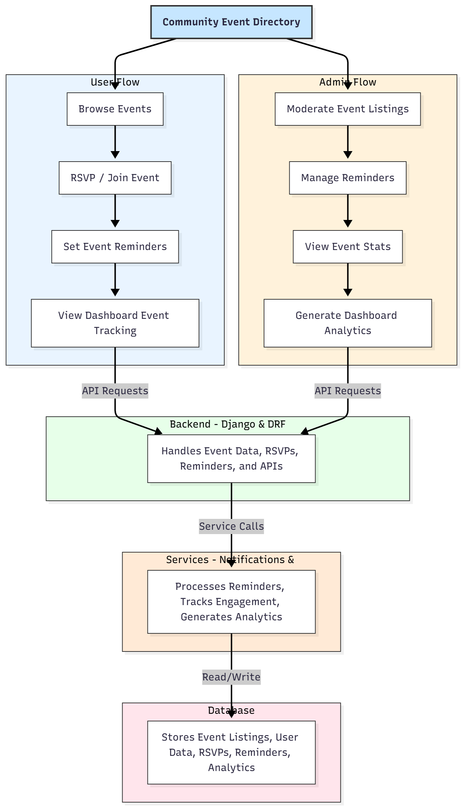

WORKING OF THE PROJECT:
Users access the platform to browse events based on categories, location, or date. They can RSVP to events they are interested in, and set reminders for upcoming events. The backend processes these requests, updates the database, and triggers notifications. Administrators moderate event listings, manage reminders, and review participation through dashboard analytics. Services handle real-time notifications and generate charts to track engagement and attendance. All event, RSVP, and user data is stored securely in the database, ensuring a seamless, organized, and interactive experience for both users and administrators..

SOFTWARE REQUIREMENT:
- Backend:
  - Python 3.x
  - Django
  - Django REST Framework
  - SQLite/PostgreSQL
- Frontend:
  - Node.js and npm
  - React.js
  - Axios
- Development Tools:
  - Visual Studio Code
  - Postman (for testing APIs)
  - Git/GitHub (for version control)
- Server/Deployment (Optional):
  - Gunicorn, Nginx, or Heroku/AWS for hosting

ADVANTAGES OF THE PROJECT:

• Centralized platform for community event management
• RSVP tracking and reminder notifications
• Dashboard analytics for user engagement and event performance
• Reduced scheduling conflicts and improved participation
• Easy moderation of event listings by administrators
• Scalable for small groups to large community organizations
• User-friendly interface with map-based visualization
• Secure data management and efficient workflow

APPLICATIONS OF THE PROJECT:
• Residential societies and community groups
• Leisure and hobby clubs
• Local event organizers and marketers
• Educational institutions
• Corporate team-building and community outreach events
• Cultural, social, and recreational event tracking

REFERENCES:

- Django REST Framework Documentation — Django Software Foundation. Django Documentation. Available: https://docs.djangoproject.com/
- Django REST Framework. DRF Documentation. Available: https://www.django-rest-framework.org/
- React. React Official Documentation. Available: https://reactjs.org/docs/getting-started.html
- Redux. Redux Documentation. Available: https://redux.js.org/introduction/getting-started
- PostgreSQL Global Development Group. PostgreSQL Documentation. Available: https://www.postgresql.org/docs/
- MySQL. MySQL Reference Manual. Available: https://dev.mysql.com/doc/
- Git. Git Documentation. Available: https://git-scm.com/doc
- Node.js. Node.js Documentation. Available: https://nodejs.org/en/docs/
- Axios. Axios Documentation. Available: https://axios-http.com/docs/intro
- Socket.io Documentation – https://socket.io/docs/

